LAB Logbook

Lab 1
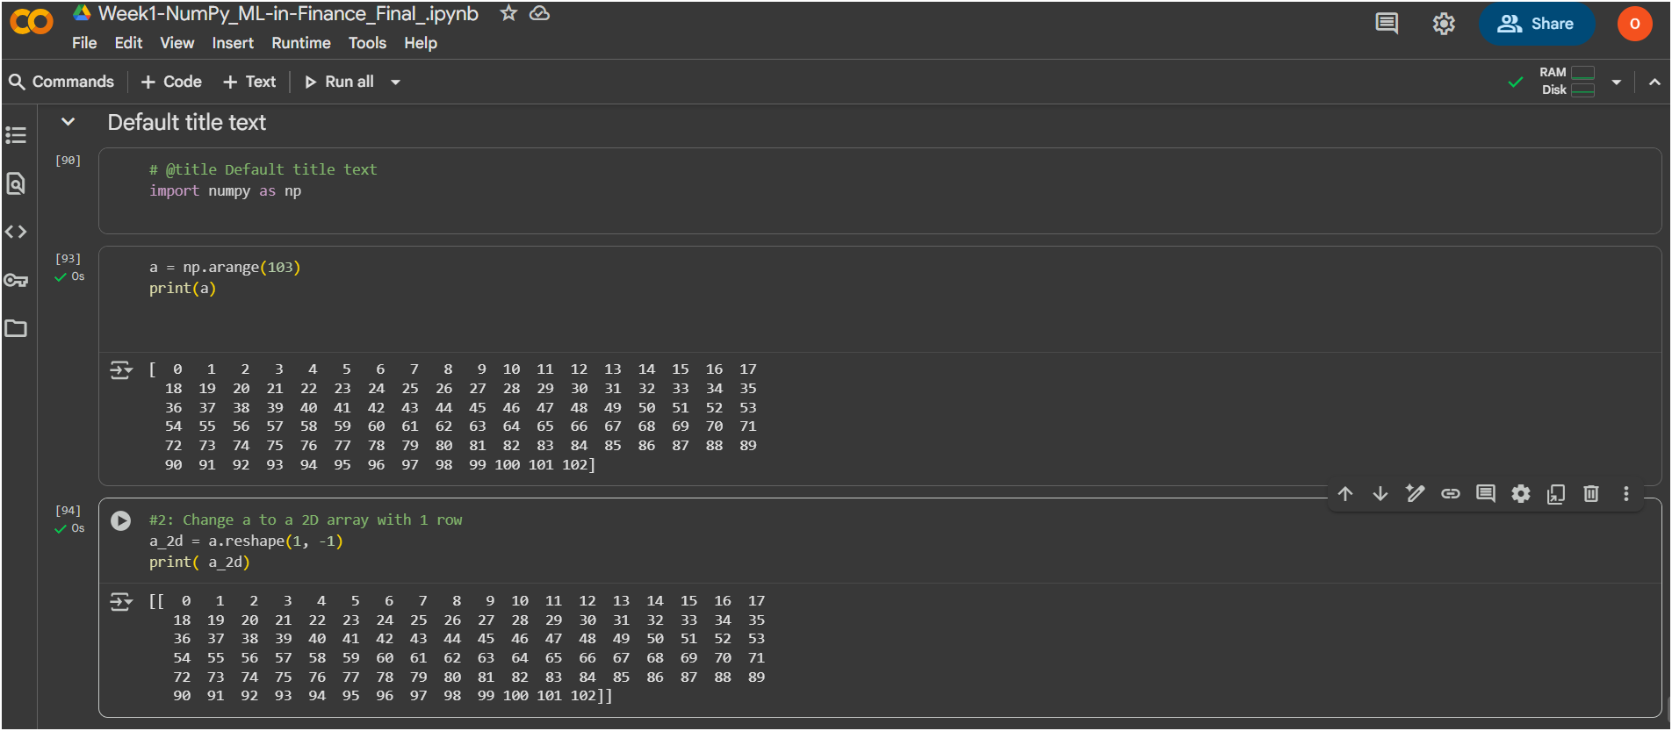
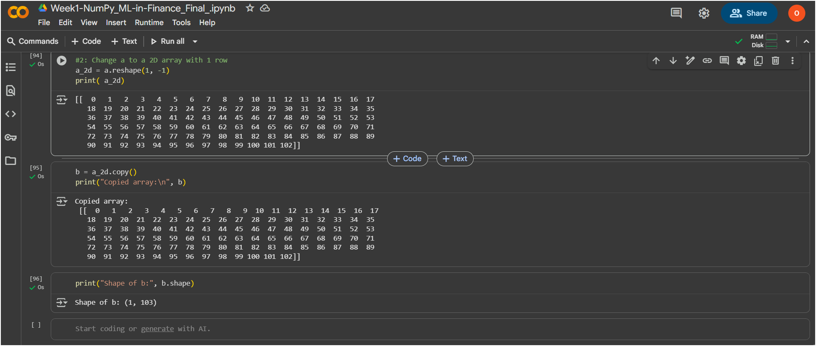

Lab 2
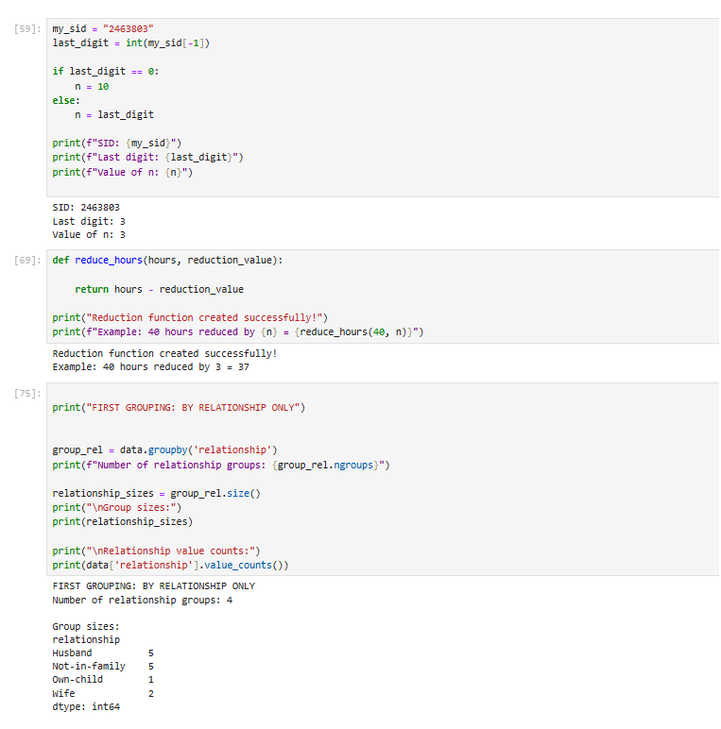
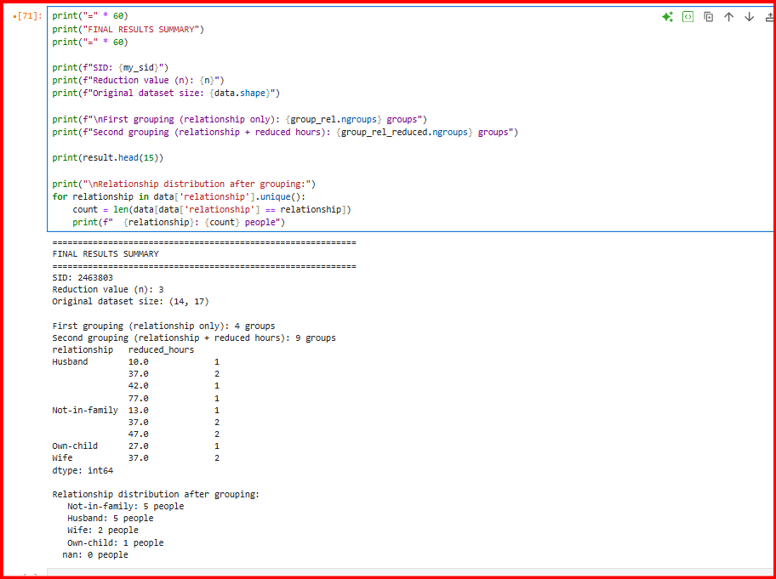

Lab 3
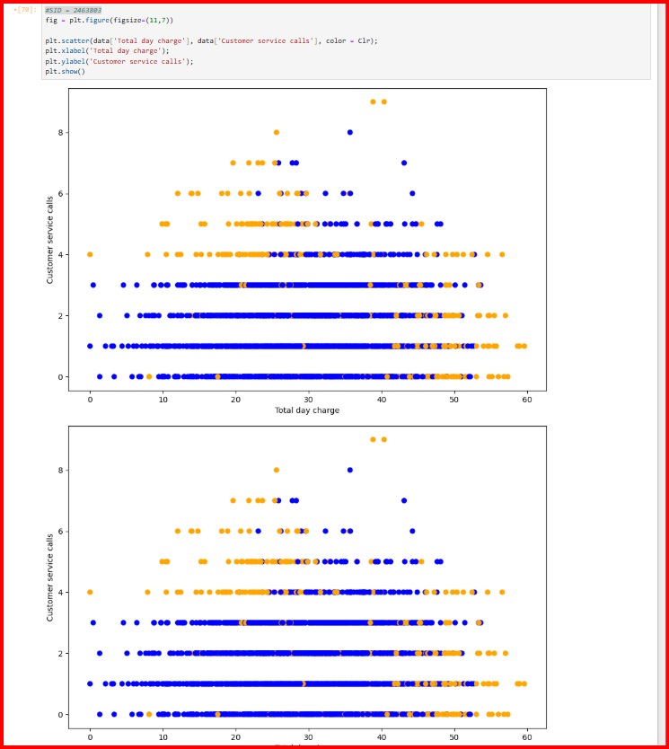

Lab 4
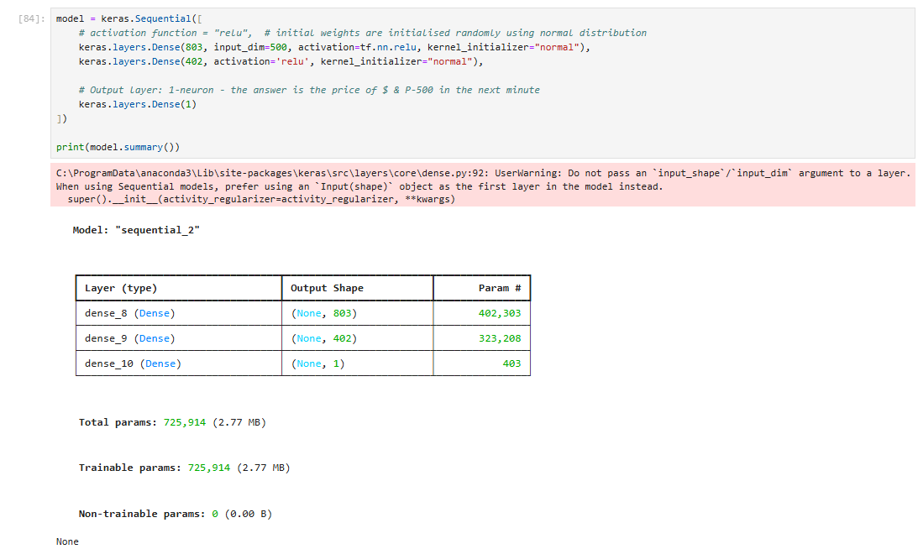
MLP architecture

MLP Training Code and process

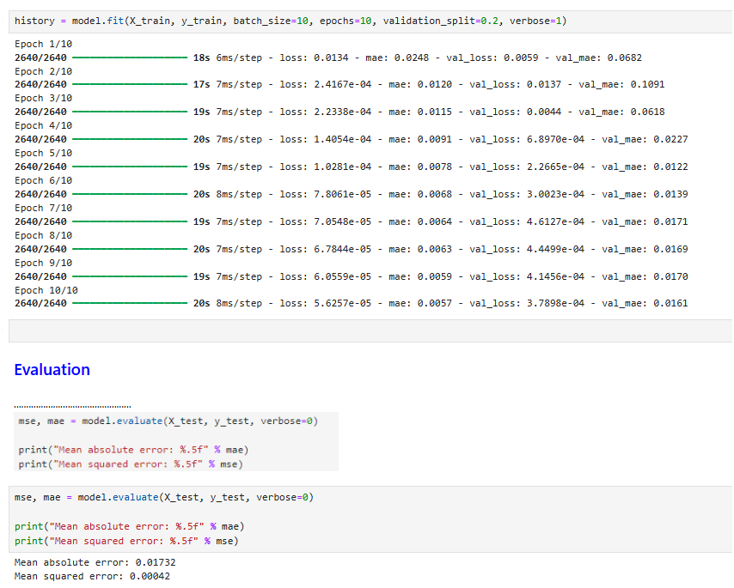

Resulting MAE on the test data

Lab 5

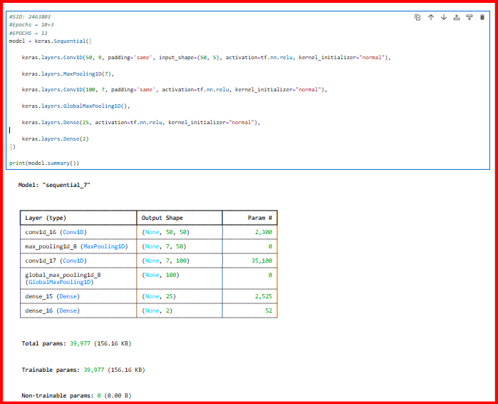

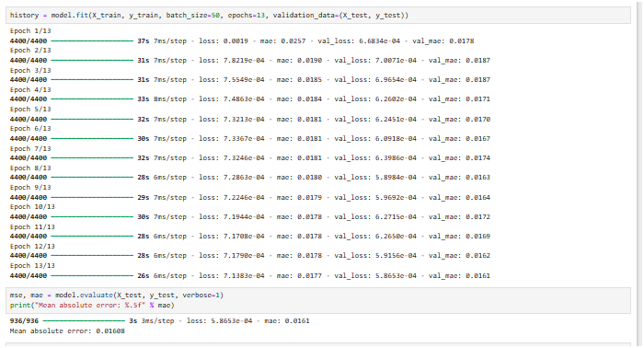

Lab 6
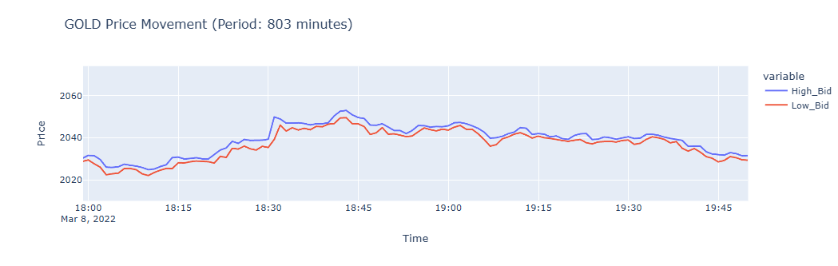
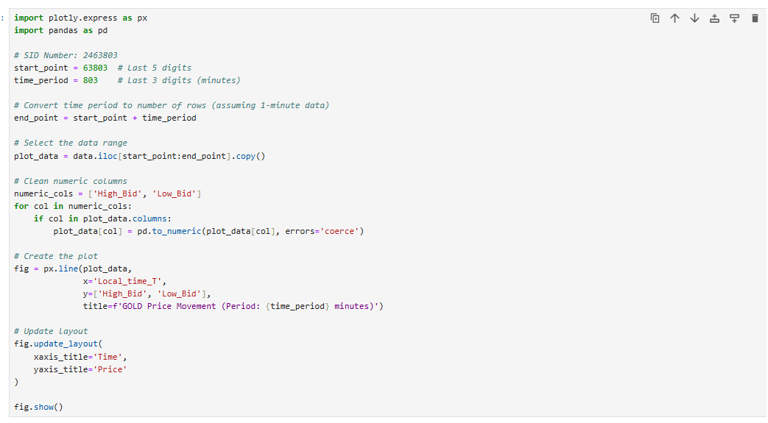

Lab 7

LSTM architecture using model.summary()

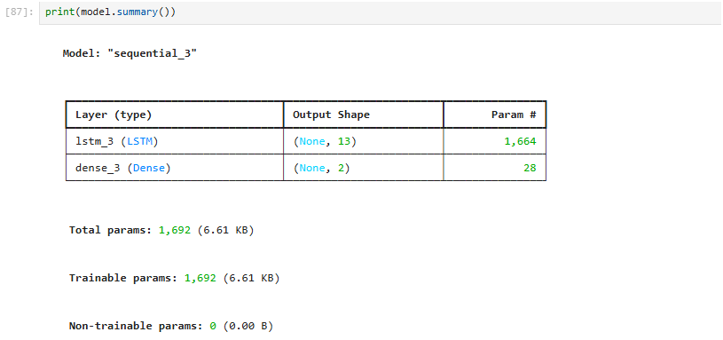
The Resulting Test MSE & MAE
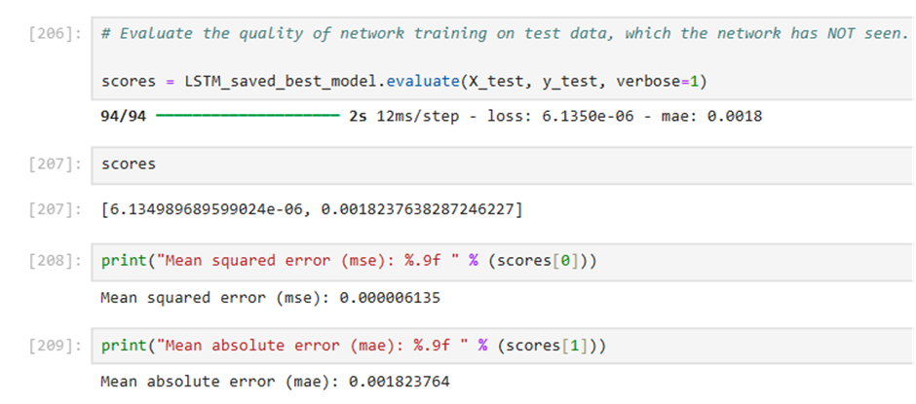
Training Process
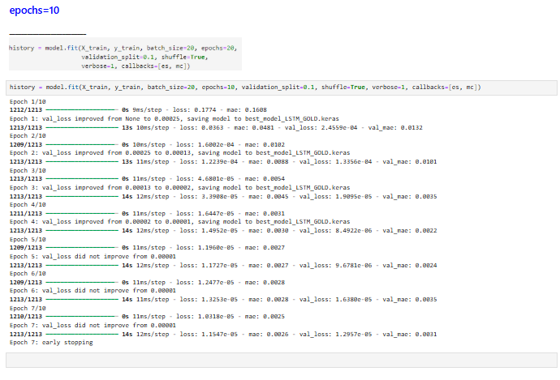

MAE Detailed Graph
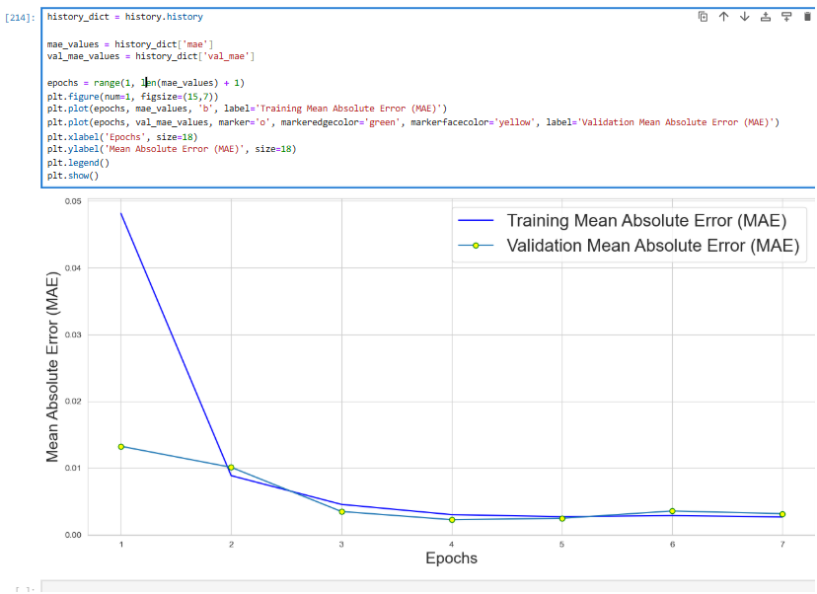

Lab 8

Lab 9

Lab 10
history = model.fit(X_train, y_train, batch_size=13, epochs=33, validation_split=0.2, shuffle=True, verbose=1, callbacks=[es, mc], class_weight=class_weight_dict
)

Lab 11

Lab 12

